Date :19.10.2022

Name : Karthikeyan.r

Roll No :611719104008

# Assignment3-BuildCNNModelForClassificationOfFlowers

1. Unzipdataset

!unzip'/content/Flowers-Dataset.zip'

Archive:/content/Flowers-Dataset.zip



inflating: flowers/daisy/100080576_f52e8ee070_n.jpginflating:flowers/daisy/10140303196_b88d3d6cec.jpg

inflating: flowers/daisy/10172379554_b296050f82_n.jpginflating: flowers/daisy/10172567486_2748826a8b.jpg

inflating: flowers/daisy/10172636503_21bededa75_n.jpginflating: flowers/daisy/102841525_bd6628ae3c.jpg

inflating: flowers/daisy/10300722094_28fa978807_n.jpg

inflating: flowers/daisy/1031799732_e7f4008c03.jpg

inflating: flowers/daisy/10391248763_1d16681106_n.jpginflating: flowers/daisy/10437754174_22ec990b77_m.jpginflating: flowers/daisy/10437770546_8bb6f7bdd3_m.jpginflating: flowers/daisy/10437929963_bc13eebe0c.jpg

inflating: flowers/daisy/10466290366_cc72e33532.jpginflating: flowers/daisy/10466558316_a7198b87e2.jpginflating: flowers/daisy/10555749515_13a12a026e.jpginflating:flowers/daisy/10555815624_dc211569b0.jpg

inflating: flowers/daisy/10555826524_423eb8bf71_n.jpginflating: flowers/daisy/10559679065_50d2b16f6d.jpg

inflating: flowers/daisy/105806915_a9c13e2106_n.jpginflating: flowers/daisy/10712722853_5632165b04.jpginflating:flowers/daisy/107592979_aaa9cdfe78_m.jpg

inflating: flowers/daisy/10770585085_4742b9dac3_n.jpginflating: flowers/daisy/10841136265_af473efc60.jpg

inflating: flowers/daisy/10993710036_2033222c91.jpg

inflating: flowers/daisy/10993818044_4c19b86c82.jpginflating: flowers/daisy/10994032453_ac7f8d9e2e.jpginflating:flowers/daisy/11023214096_b5b39fab08.jpg

inflating: flowers/daisy/11023272144_fce94401f2_m.jpginflating: flowers/daisy/11023277956_8980d53169_m.jpginflating: flowers/daisy/11124324295_503f3a0804.jpg

inflating: flowers/daisy/1140299375_3aa7024466.jpginflating:flowers/daisy/11439894966_dca877f0cd.jpg

inflating: flowers/daisy/1150395827_6f94a5c6e4_n.jpginflating: flowers/daisy/11642632_1e7627a2cc.jpg

inflating: flowers/daisy/11834945233_a53b7a92ac_m.jpg

inflating: flowers/daisy/11870378973_2ec1919f12.jpg

inflating: flowers/daisy/11891885265_ccefec7284_n.jpginflating: flowers/daisy/12193032636_b50ae7db35_n.jpginflating: flowers/daisy/12348343085_d4c396e5b5_m.jpginflating: flowers/daisy/12585131704_0f64b17059_m.jpginflating: flowers/daisy/12601254324_3cb62c254a_m.jpginflating: flowers/daisy/1265350143_6e2b276ec9.jpg



inflating: flowers/daisy/12701063955_4840594ea6_n.jpginflating: flowers/daisy/1285423653_18926dc2c8_n.jpginflating: flowers/daisy/1286274236_1d7ac84efb_n.jpginflating: flowers/daisy/12891819633_e4c82b51e8.jpg

inflating: flowers/daisy/1299501272_59d9da5510_n.jpginflating: flowers/daisy/1306119996_ab8ae14d72_n.jpginflating: flowers/daisy/1314069875_da8dc023c6_m.jpginflating: flowers/daisy/1342002397_9503c97b49.jpg

inflating: flowers/daisy/134409839_71069a95d1_m.jpginflating:flowers/daisy/1344985627_c3115e2d71_n.jpg

inflating: flowers/daisy/13491959645_2cd9df44d6_n.jpginflating: flowers/daisy/1354396826_2868631432_m.jpginflating: flowers/daisy/1355787476_32e9f2a30b.jpg

inflating: flowers/daisy/13583238844_573df2de8e_m.jpginflating: flowers/daisy/1374193928 a52320eafa.jpg

# ImportingNecessaryLibraries

importwarnings

warnings.filterwarnings("ignore")

importnumpyasnp

import matplotlib.pyplot as pltimportpandas as pd

fromtensorflow.keras.modelsimportSequential

from tensorflow.keras.layers import Dense,Activation,Dropout,Conv2D,Flatten,MaxPool2D,Reshfromtensorflow.keras.applications.resnet50 importResNet50

from tensorflow.keras.applications.resnet50 import preprocess_inputfromtensorflow.keras.preprocessing importimage

from tensorflow.keras.preprocessing.image import ImageDataGenerator,load_img,img_to_arrayfromtensorflow.keras.callbacksimportEarlyStopping, ReduceLROnPlateau

# ImageAugumentation

Datasetconsistof5classes.

**Daisy**-EuropeanSpeciesofAsterfamily.

**Sunflower**-IdentifiedasthegenusofHelianthus.

**Tulip**-Itbelongstothespeciesofspringbloominggeophytes.

**Rose**-Itbelongstothefamilyofrosaceae.

**Dandelion**-IndentifiesasthegenusofAsterceae.

path ='flowers/'

train_data_gen=ImageDataGenerator(rescale =1./255,

shear_range=0.2,

zoom_range=0.2,

horizontal_flip = True,validation_split=0.30)

test_data_gen=ImageDataGenerator(rescale =1./255,validation_split=0.30)

training_set= train_data_gen.flow_from_directory(path,

target_size=(64,64),batch_size=100,

class_mode='categorical',shuffle=True,

color_mode='rgb',

subset='training')

testing_set= test_data_gen.flow_from_directory(path,

target_size=(64,64),batch_size=100,

class_mode='categorical',shuffle=True,

color_mode='rgb',

subset='validation')

Found 3024 images belonging to 5 classes.Found1293imagesbelongingto5classes.

# Createthemodel

model = Sequential()

# AddLayers(Convolution,MaxPooling,Flatten,Dense-HiddenLayers,Output)

#convolution and Pooling layer 1

model.add(Conv2D(filters=48,kernel_size=3,activation='relu',input_shape=(64,64,3)))model.add(MaxPool2D(pool_size=2,strides=2))

model.add(Dropout(0.2))

#convolution and Pooling layer 2

model.add(Conv2D(filters=32,kernel_size=3,activation='relu'))model.add(MaxPool2D(pool_size=2,strides=2))

model.add(Dropout(0.2))

#Flattening the imagesmodel.add(Flatten())

#Fully Connected layers

model.add(Dense(64,activation='relu'))model.add(Dropout(0.2))

model.add(Dense(5,activation='softmax'))model.summary()

Model: "sequential"

Layer (type) Output Shape Param #

=================================================================

|  |  |  |  |  |
| --- | --- | --- | --- | --- |
| conv2d (Conv2D) | (None, 62, 62, 48) | | | 1344 |
| max_pooling2d (MaxPooling2D | (None, 31, 31, 48) | | | 0 |
| ) |  | | |  |
| dropout (Dropout) | (None, 31, 31, 48) | | | 0 |
| conv2d_1 (Conv2D) | (None, 29, 29, 32) | | | 13856 |
| max_pooling2d_1 (MaxPooling2D) | (None, 14, 14, 32) | | | 0 |
| dropout_1 (Dropout) | (None, | 14, 14, | 32) | 0 |
| flatten (Flatten) | (None, | 6272) |  | 0 |
| dense (Dense) | (None, | 64) |  | 401472 |
| dropout_2 (Dropout) | (None, | 64) |  | 0 |
| dense_1 (Dense) | (None, | 5) |  | 325 |

=================================================================

Total params: 416,997

Trainable params: 416,997

Non-trainable params: 0

# CompilingtheModel

model.compile(loss='categorical_crossentropy',optimizer='adam',metrics=['accuracy'])

# FittingtheModel

early_stop=EarlyStopping(monitor='val_accuracy',

patience=5,verbose=1,mode='auto')

lr=ReduceLROnPlateau(monitor='val_accuracy',

factor=0.2,patience=5,min_lr=0.00001)

callback = [early_stop,lr]

TrainingtheModel

result=model.fit(x=training_set, validation_data=testing_set,epochs=10)

|  |  |  |  |  |  |  |  |  |
| --- | --- | --- | --- | --- | --- | --- | --- | --- |
| Epoch  31/31 | 1/10  [==============================] | - 30s | | 966ms/step | - loss: | 0.7625 | - accuracy: | 0 |
| Epoch | 2/10 |  | |  |  |  |  |  |
| 31/31  Epoch31/31 | [==============================]3/10  [==============================] | - 30s  - 31s | | 969ms/step  985ms/step | * loss: * loss: | 0.7454  0.7348 | * accuracy: * accuracy: | 0  0 |
| Epoch  31/31 | 4/10  [==============================] | - 30s | | 968ms/step | - loss: | 0.7144 | - accuracy: | 0 |
| Epoch | 5/10 |  | |  |  |  |  |  |
| 31/31  Epoch | [==============================]  6/10 | - 31s | | 992ms/step | - loss: | 0.7233 | - accuracy: | 0 |
| 31/31  Epoch | [==============================]7/10 | - | 32s | 1s/step - loss: 0.7017 - accuracy: 0.73 | | | | |
| 31/31 | [==============================] | - 30s | | 963ms/step | - loss: | 0.6715 | - accuracy: | 0 |
| Epoch  31/31 | 8/10  [==============================] | - 31s | | 978ms/step | - loss: | 0.6512 | - accuracy: | 0 |
| Epoch | 9/10 |  | |  |  |  |  |  |
| 31/31  Epoch31/31 | [==============================]10/10  [==============================] | - 31s  - 30s | | 982ms/step  974ms/step | * loss: * loss: | 0.6711  0.6481 | * accuracy: * accuracy: | 0  0 |

LossandAccuracycheckusingplot

#plot the loss

plt.plot(result.history['loss'],label='trainloss')

plt.plot(result.history['val_loss'], label='val loss')plt.legend()

plt.show()

# plot the accuracy

plt.plot(result.history['accuracy'], label='train acc')plt.plot(result.history['val_accuracy'], label='val acc')plt.legend()

plt.show()

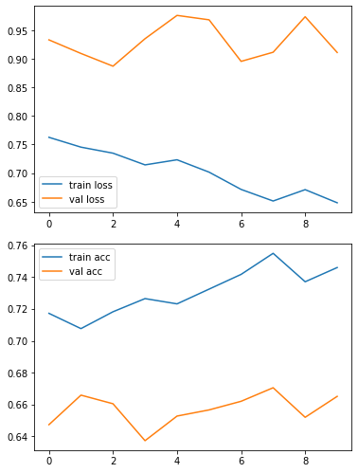

7.SavingtheModel

model.save('daisy.h5')

8.TestingtheModel

training_set.class_indices

classes = ['Daisy','Dandelion','Rose','Sunflower','Tulip']deftesting(img):

img = image.load_img(img,target_size=(64,64))x = image.img_to_array(img)

x=np.expand_dims(x,axis=0)

pred = np.argmax(model.predict(x))

returnprint("Predictedclassas:",classes[pred])

defimg_show(img):

img1 = image.load_img(img,target_size=(64,64))plt.imshow(img1)

#test1

img_show('/content/flowers/sunflower/12471443383_b71e7a7480_m.jpg')testing('/content/flowers/sunflower/12471443383_b71e7a7480_m.jpg')

Predicted class as: Sunflower

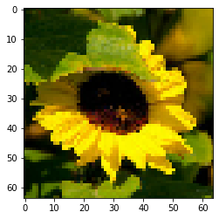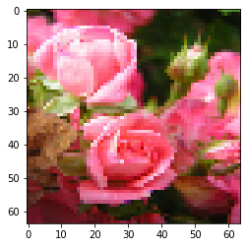

#test3

img_show('/content/flowers/dandelion/2116997627_30fed84e53_m.jpg')testing('/content/flowers/dandelion/2116997627_30fed84e53_m.jpg')

Predicted class as: Daisy

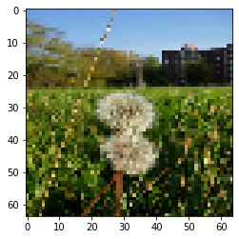

#test4

img_show('/content/flowers/daisy/1314069875_da8dc023c6_m.jpg')testing('/content/flowers/daisy/1314069875_da8dc023c6_m.jpg')

Predicted class as: Daisy

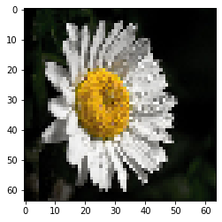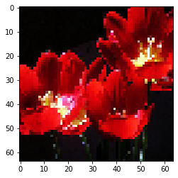

**Conclusion:**

**Thedatasethasabout4317imagesfrom5differentclasses.**

* 1. Eachclasseshavemorethan500imagesfortrainingthedata.
  2. 30%ofthedatatakenforvalidation.
  3. Theaccuracyofthemodelisaround80%.
  4. Thevalidationaccuracyisaround70%.
  5. Themodelisbuiltwith2layeredconvolutionalnetworkconsidering1344trainableparameters.
  6. Testingthemodelwithunknownimagesgives95%accuracy.